Read and respond

Read

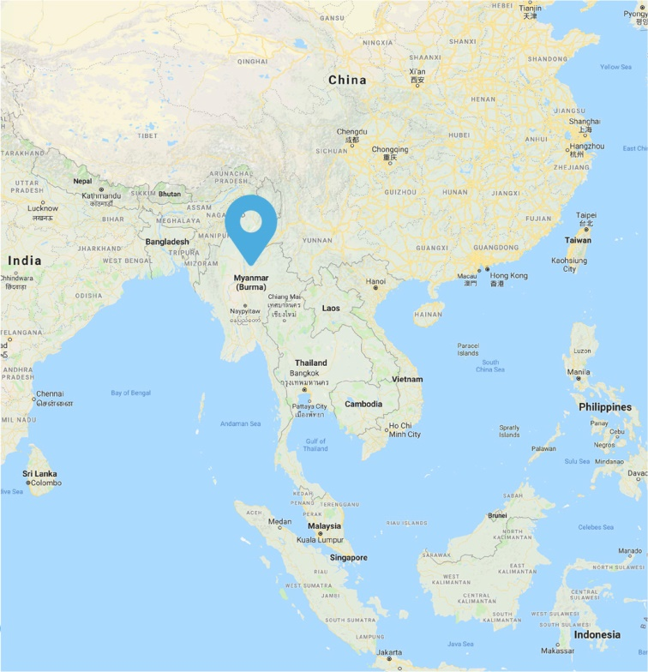
Myanmar, a country in South East Asia
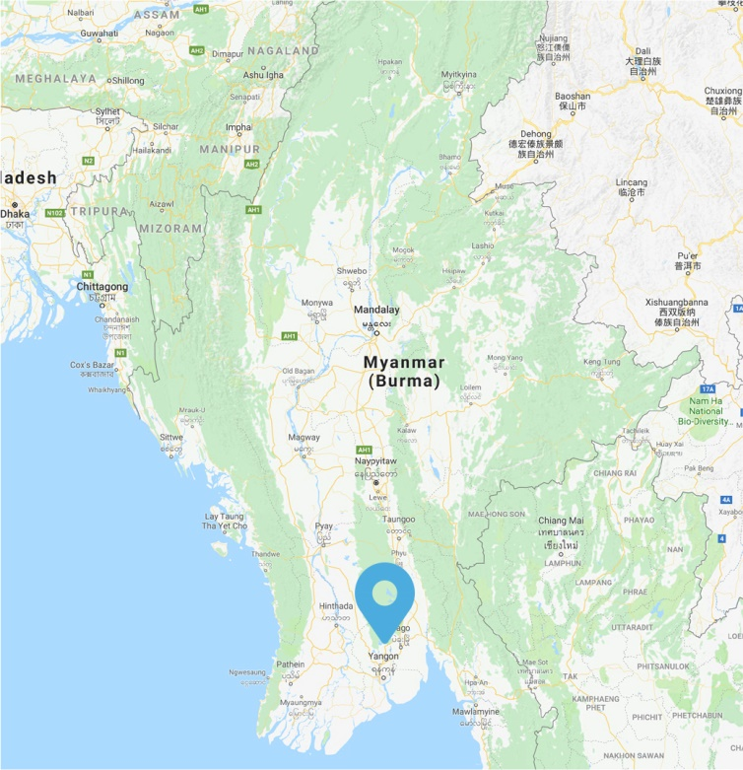
Yangon is the capital of the Yangon Region of Myanmar, also known as Burma

The Country

Myanmar is the largest country in mainland South-East Asia and is bordered by China, Bangladesh, India and Thailand. It has a diverse population of around 53 million people with approximately 135 separate ethnic groups. Despite its size and location, Myanmar is also placed in the lower half of the region’s economies, with around one quarter of its population estimated to be living below the poverty line. The main religion in Myanmar is Buddhism, with around 88 percent of the population identifying as such. Myanmar’s 14 administrative divisions are divided into seven states (all of which are inhabited mostly by the dominant Bamar ethnic group) and seven regions (each inhabited by particular ethnic minorities).

Myanmar is a geographically diverse country, with low-lying regions around the Irrawaddy delta in the south and mountainous regions in the north, with many peaks rising above 5,000m. The geography of the country also lends itself to isolation. Some towns and cities are accessible by only one major route, and the journey can take many hours. Others are accessible only by water or air.

Read continued…
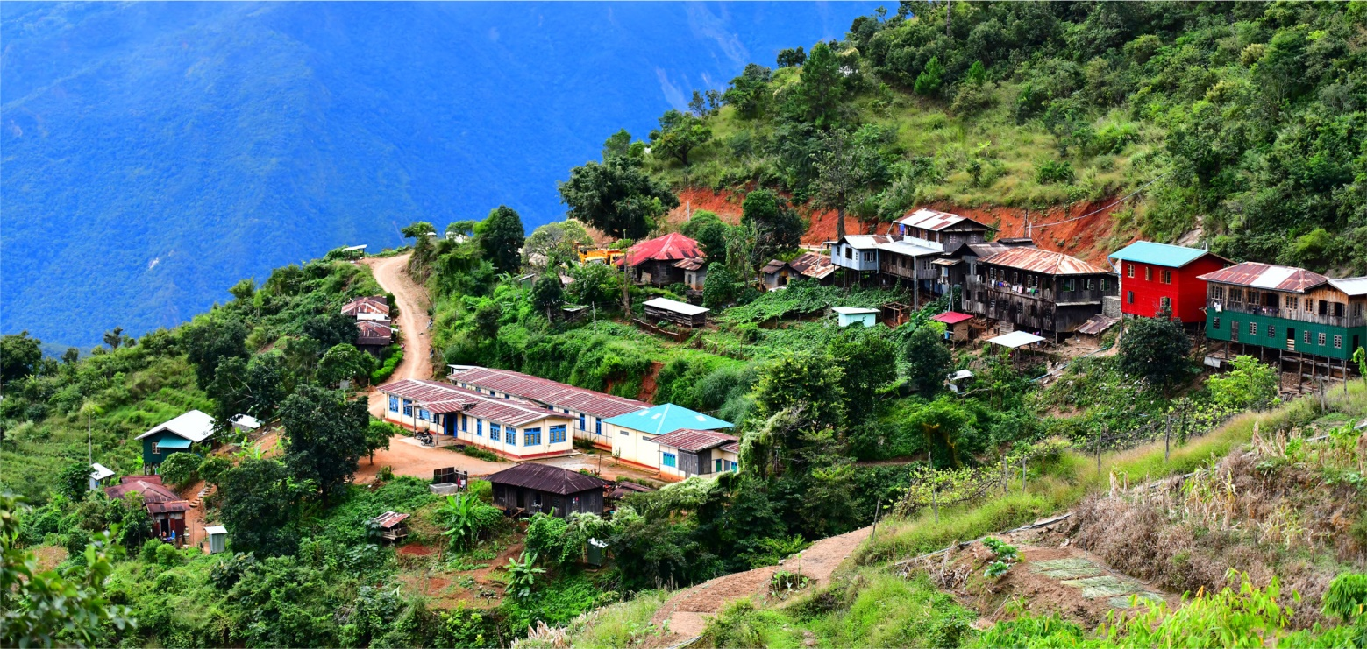
A rural village in Myanmar near Hakka Diocese

The first unified state of Myanmar was founded by King Anawrahta at Bagan in 1065. For over 800 years, Burma, as it was known, remained a kingdom, ruled by various dynasties until it came under British occupation in 1885.
In 1948, Burma became an independent republic. Fourteen years later, after a short-lived Japanese occupation, a military junta led by General Aung Win took control of Burma, expelling all foreign missionaries and nationalising the nation’s education system.
In 1990, supposedly democratic national elections were held, though the result, which had the opposition National League for Democracy claiming victory in a landslide, was ignored by the ruling military.
Much of Myanmar’s modern history has been characterised by civil and ethnic conflict. Active conflict zones still exist in parts of the country, including the
Rakhine, Shan, Kachin and Kayin states. For much of their period of independence, Myanmar closed its borders to foreigners. This, along with accusations of human rights impingements, drew widespread condemnation from the international community.
It wasn’t until 2011 that the military relinquished its hold on the government, beginning a transition to a nominally civilian government. In 2015, the first truly democratic elections were held and the result—the NLD again winning—was acknowledged. The leader of the NLD, Nobel Prize Laureate Aung San Suu Kyi, was constitutionally banned from becoming president, however she assumed the role of State Counsellor and retains significant influence in national affairs.
United Nations Population Fund: https://www.unfpa.org/data/worldpopulation/MM
(Accessed 13th March 2018)

St Joseph’s Centre for Children and Adults with HIV-AIDS

St Joseph’s Centre for Children and Adults with HIV/AIDS is a specialist home in Kalay, established by the Sisters of St Joseph of the Apparition to address a widening gap identified in the local community.
While there is treatment available at nearby hospitals for patients who are HIV-positive, there was little care offered for patients outside of their treatment times, or for their children while they were either receiving or recovering from treatment. The sisters set up the St Joseph’s Home so children of HIV-positive parents, some of whom are orphaned, and some of whom are HIV-positive themselves, can stay without fear of discrimination, abandonment or hunger.
The home is like a boarding house, where children live, learn and play together. They are encouraged to keep their rooms tidy and help the Sisters with household jobs.
Thanks to the committed lobbying of the Sisters, many of the children also have a chance to go to school at nearby St Patrick’s, which has adopted a child-centred approach to education. Some of the teachers have graduated from the teacher-training program offered by the Bishops Commission for Education, which is funded by Catholic Mission.
The opportunity to attend school with other children they would normally have been isolated from is helping to break down stigma in the local community, ensuring an equal education for all children. The children from the St Joseph’s Home can come to school, meet new friends, and learn new things—a huge step forward in their lives.
For five-year-old Victoria*, who was born HIV-positive, St Joseph’s is the only family she has known. At the age of just two, she lost her entire family to the virus and was brought under the care of the sisters, who discovered her at the hospital. She now attends kindergarten at St Patrick’s School, and has made many new friends. Victoria loves to draw, and when she is older, she would like to be a Sister, like those who have cared for her.
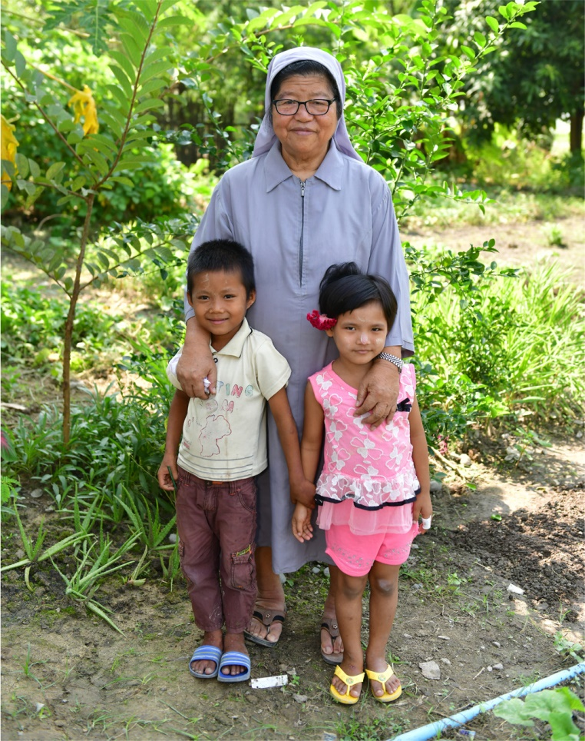
Children from St Joseph’s Home

Respond

Some questions
Where is Myanmar located?
When was the first truly democratic election in Myanmar?
Who won the election? What is her role in the country?
Where in Myanmar is Kalay?
What is a child-centred approach to education?
Why is the St Joseph’s Centre for Children and Adults with HIV/AIDS so important?
How are children with HIV/AIDS generally treated by the rest of the community in Myanmar?
Why do you think the nuns had to lobby for the children to be able to go to school?

Extension

The Rohingya people of Myanmar
You may have heard or read about the problems facing the Rohingya people of Myanmar.
Have you ever wondered about what you have heard? What is the Rohingya crisis?
Cardinal Bo from Myanmar may provide you with some extra information and some answers to your questions.
Read Cardinal Bo’s statement here:
www.zenit.org.articles/myanmar-cardinal-bo-explains-the-rohingya-issue/
- What could you do to learn more about someone who is from a different country and culture than your own?
- How could you help to make a ‘stranger’ feel welcome?

Share the Journey
Go to the Advocacy pages to see how you could hold your own ‘Share the Journey’ event and help create a more harmonious world.
www.WMM2018.cm.org.au/advocacy--share-the-journey.html

